International Journal of Operations Research Vol. **, No. 1, ^^−^^ (2022)
International Journal of
Operations Research

Author’s Instruction for Preparing Papers in International Journal of Operations Research

Author 1¹, Author 2¹, and Author 3²

¹Department of Xxxxxxx Engineering, University of Xxxxxxxx
Street Address, Address Line 2, City, State 60607

²Department of Xxxxxxx Engineering, University of Xxxx,
Street Address Address Line 2, City, State 60607

Abstract: This article illustrates the preparation of the manuscript using MS-WORD. All papers should be submitted as MS-WORD documents, and the document size should not exceed 3 MB. Papers are not limited to 10 pages. Pages should not be numbered, and the abstract should not exceed 150 words. Please leave one blank space (10 pt.) between each of the following: title, author’s names, affiliations, addresses, and the abstract. To be properly reproduced in the Proceedings, the margins of this template should be set for A4 size paper to 25 mm on the sides, 25 mm on top, and 25 mm on the bottom. The paper begins with a title in bold, which uses 14pt Garamond, followed by the details for each author in 10pt Garamond. Section titles are bolded in 10pt Garamond, and the body of the paper should be typed in 10pt Garamond. Should there be any questions on the format, please direct queries to ijor.orstw@gmail.com.
Keyword -- Maximal 5 keywords.

1. INtroduction

The spacing between the abstract and the text heading is two line spaces (10 pt.). All major headings should be numbered, capitalized, and in 10 pt. Bold. The first paragraph of each section should not be indented. The first paragraph after any section title should be indented (7.5 mm) with one line space before the paragraph.
All subsequent paragraphs should be indented as here with no line spacing between paragraphs. Two line spaces (10 pt.) should follow each section.

1.1 Second-Level Heading

The first paragraph after any section title should not be indented as here with one line space before the paragraph.
The second and all subsequent paragraphs should be indented (7.5 mm) as here with no line spacing before the line.

1.1.1 Third-Level Heading

The first paragraph after any section title should not be indented as here with one line space before the paragraph.
The second and all subsequent paragraphs should be indented as here with no line spacing before the line. Avoid using more than three levels of headings.

2. Equations

Equations should be numbered consecutively, beginning with (1) to the end of the paper. The number should be enclosed in parenthesis and set flush right in the column on the same line as the equation. An extra space line should be left above and below a displayed equation or formula.

(1)

3. figures and tables

All figures should be positioned at the top of the page when possible. All figures should be numbered consecutively and captioned; the caption should be centered under the figure, as shown in Figure 1. All text within the figure should be no smaller than 9pt. There should be a minimum of two line spaces between figures and text.

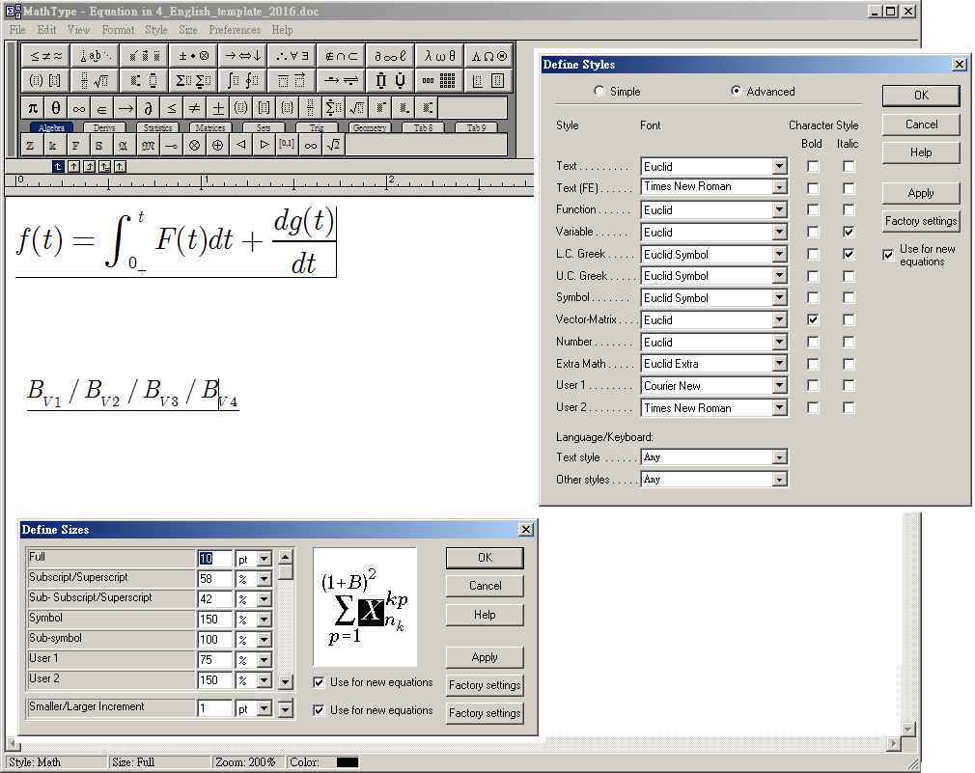

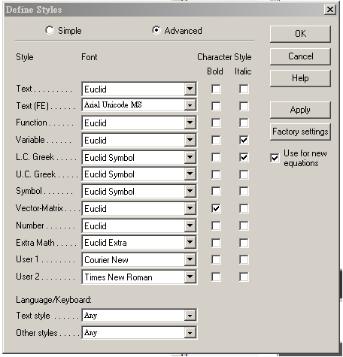

Figure 1. Format for Math equations.

All tables should be numbered consecutively and captioned; the caption should be centered above the table, as shown in Table 1. The body of the table should be no smaller than 9 pt. There should be a minimum of two line spaces between tables and text.

Table 1. Title of Table

Format for Table

4. CITING REFERENCES

Within the text, references should be cited, giving the last name of the author(s) and the year of publication of the reference. The year should always be enclosed in parentheses; the authors’ name (s) should be enclosed within the parentheses, depending on the context—for example, Mital (1993) or (Mital, 1993).
References should be listed together at the end of the paper. References should be arranged in alphabetical order according to the author’s last name or the first-named author's last name for papers with more than one author. Refer to the examples shown below.

REFERENCES

- Insignia: Insignia Solutions Home Page. Mital, A. and Anand, S. (Eds.)(1993). Handbook of Expert Systems in Manufacturing: Structure and Rules, Chapman & Hall, London, United Kingdom.
- Java: Java Home Page. http://java.sun.com/
- Kuo, T. and Mital, A. (1993). Quality Control Expert Systems: A Review of Pertinent Literature. Journal of Intelligent Manufacturing Systems, 4: 245-257.
- Mital, A. (1988). Desirability of Robots. In International Encyclopedia of Robotics (Ed.: R.C. Dorf), Wiley-Interscience, New York, 322-329.
- Mital, A. and Mahajan, A. (1989). Impact of Production Volume and Wage and Interest Rates on Economic Decision Making: The Case of Automated Assembly. Proceedings of the Conference of Society for Integrated Manufacturing, Institute of Industrial Engineers, 558-563.
- Mital, A., Nicholson, A.S., and Ayoub, M.M. (1993). A Guide to Manual Materials Handling, Taylor & Francis, Ltd., London, United Kingdom.

Corresponding author’s e-mail: author@xxx.xxx

